ME-Israel-Jewish-Babylonian Incantation bowl with Aramaic inscription-6th-7th c CE

https://tmpl-resources.auctiva.com/resources/static/images/spacer.gif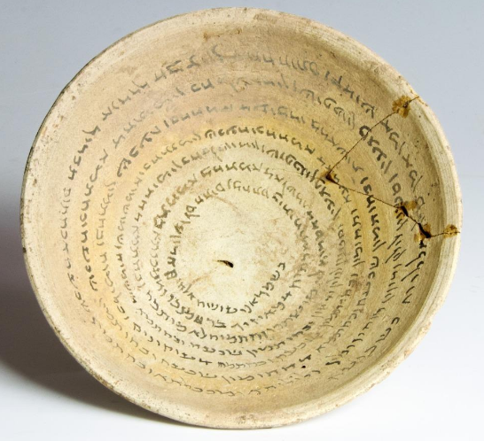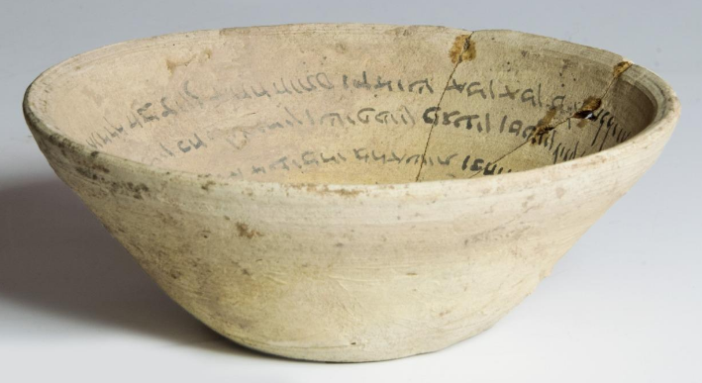

ME-Israel-Jewish-Babylonian Incantation bowl with Aramaic inscription-6th-7th c CE

**Case no.:**

**Accession Number:**

**Formal Label:**

**Display Description:**

Cream-colored Incantation bowl with an Aramaic inscription written on the inside in black ink, in a continuous spiral comprising 8 bands of good clear Aramaic script. Such incantations were written individually, according to need and in answer to a specific order placed by a client, executed by a professional, the magician or practitioner. They could be a spell to banish evil spirits, a spell to protect the life of a new-born, a divorce formula, etc. Often biblical verses can be included to those ends. The formulae inscribed on magic bowls represent the only significant epigraphic corpus of Jewish Babylonian Aramaic from this period.

**LC Classification:**

**Date or Time Horizon:**

**Geographical Area:**

**Map:**

**GPS coordinates:**

**Cultural Affiliation:**

**Media:**

**Dimensions:** Diameter 15.75 cms (6.2 ins)

**Weight:**

**Condition:** One section broken/repaired, otherwise complete.

**Provenance:** This item is not a UK find and as such is not subject to the Portable Antiquities Scheme. Purchased from a prominent London dealer and previously reputedly part of a private collection built up in Jordan in the 1930s, exported under license by the Jordanian authorities in 1988  
Supplied with illustrated COA.

**Discussion:**

**References:**